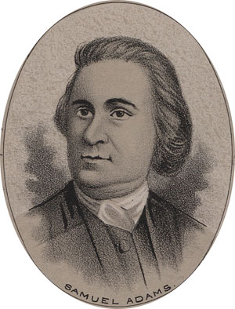
Samuel Adams: “American Independence”
COUNTRYMEN AND BRETHREN: I would gladly have declined an honor, to which I find myself unequal. I have not the calmness and impartiality which the infinite importance of this occasion demands. I will not deny the charge of my enemies, that resentment for the accumulated injuries of our country, and an ardor for her glory, rising to enthusiasm, may deprive me of that accuracy of judgment and expression which men of cooler passions may possess. Let me beseech you, then, to hear me with caution, to examine without prejudice, and to correct the mistakes into which I may be hurried by my zeal.
Men who content themselves with the semblance of truth, and a display of words, talk much of our obligations to Great Britain for protection! Had she a single eye to our advantage? A nation of shopkeepers is very seldom so disinterested. Let us not be so amused with words: the extension of her commerce was her object. When she defended our coasts, she fought for her customers, and convoyed our ships loaded with wealth, which we had acquired for her by our industry. She has treated us as beasts of burden, whom the lordly masters cherish that they may carry a greater load. Let us inquire also against whom she has protected us? Against her own enemies with whom we had no quarrel, or only on her account, and against whom we always readily exerted our wealth and strength when they were required. Were these colonies backward in giving assistance to Great Britain, when they were called upon in 1739, to aid the expedition against Carthagena? They at that time sent three thousand men to join the British army, although the war commenced without their consent.
Who among you, my countrymen, that is a father, would claim authority to make your child a slave because you had nourished him in his infancy?
The hand of heaven appears to have led us on to be, perhaps, humble instruments and means in the great providential dispensation which is completing. We have fled from the political Sodom; let us not look back, lest we perish and become a monument of infamy and derision to the world!
To unite the supremacy of Great Britain and the liberty of America is utterly impossible. So vast a continent and of such a distance from the seat of empire will every day grow more unmanageable. The motion of so unwieldy a body cannot be directed with any dispatch and uniformity, without committing to the Parliament of Great Britain powers inconsistent with our freedom. The authority and force which would be absolutely necessary for the preservation of the peace and good order of this continent would put all our valuable rights within the reach of that nation.
Our Union is now complete; our constitution composed, established, and approved. You are now the guardians of your own liberties. We may justly address you, as the Decemviri did the Romans, and say - "Nothing that we propose can pass into a law without your consent. Be yourselves, O Americans, the authors of those laws on which your happiness depends."
You have now in the field armies sufficient to repel the whole force of your enemies, and their base and mercenary auxiliaries. The hearts of your soldiers beat high with the spirit of freedom - they are animated with the justice of their cause, and while they grasp their swords, can look up to heaven for assistance. Your adversaries are composed of wretches who laugh at the rights of humanity, who turn religion into derision, and would, for higher wages, direct their swords against their leaders or their country. Go on, then, in your generous enterprise, with gratitude to heaven, for past success, and confidence of it in the future. For my own part, I ask no greater blessing than to share with you the common danger and common glory. If I have a wish dearer to my soul, than that my ashes may be mingled with those of a Warren and Montgomery - it is - that these American States may never cease to be free and independent!

